Intermediate Breath Hold Course – INTRODUCTION

Welcome to the intermediate breath hold course. By taking this step you are furthering your knowledge in the sport of breath hold. By discovering and understanding this ancient art, it will let you rediscover yourself. Enjoy the course and let us take you to the next level.

We will require some documentation completed from you prior to attending the course, these will be.

1. Course Enrolment
2. Medical Statement

Both these forms will be required prior to the course starting, these can handed in on the night but if there is any medical issues you will be required to get a medical to attend the course. We would prefer all forms at least 7 days prior to all courses starting.

**Risks involved**

One of the greatest risks when freediving is blackout-be it shallow water or deep water. Each year there are fatalities caused from drowning after blackout, all could have been prevented if safe diving practices had been adhered to. There are other risks associated with free diving during the first theory lesson as well as safe diving practices that we will cover to ensure we eliminate these from happening. If you feel the risks are too great and you don’t want to participate after the theory component of the course we will happily refund 70% of these course cost.

**Liability and assumption of risk document.**

This form will be completed during the first classroom session after I have explain the risks to you.

**Equipment Requirements**

You will be required to supply your own equipment for the course, please see below is required.

Open cell wetsuit is preferred (5mm minimum) gloves, booties, fins, mask, snorkel, weight belt (weights to be removable)

**Transport**: It is a requirement for all students to have their own transport

**Weekend Course Schedule**

**Friday night:** Classroom session (5:30pm – 9pm)  
Location: Ocean Hunter, 100 Gaunt St, Westhaven Ph 09 377 0896  Or your hosting club or dive shop.  
Content: The Human Body in Water: physiological and psychological aspects of breath holding, Safe Diving Practises, Freediving Equipment, Diet & Hydration, Breathing Exercises  
  
**Saturday: 8am – 4pm**  
**Location:** Pool location to be advised (8am – 12pm)

**Pool:** Breathing exercises, pre & post dive breathing, static apnea oxygen table, static apnea training & safety techniques, weighting.

**Open Water Session:** (Location  to be advised) (1.30pm – 4pm) Entry technique, rescue, equalisation, deep water techniques performed to your comfort levels concentrating on building up time spent at depth.

**Sunday: 8am – 4pm**  
  
**Location:** Pool location to be advised (8am – 12pm)

**Pool:** Preparation techniques (stretching and breathing), warm up statics, static/s, fining technique, long dynamics, CO2 dynamics, buddy rescue.  
  
**Deep Session:** (Location to be advised) (1.30pm – 4pm)  
Deep water techniques performed to your comfort levels concentrating on building up time spent at depth.

I look forward to seeing you at the course,

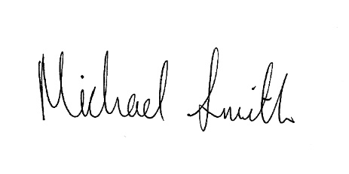

Regards

Michael Smith

Managing Director & Lead Instructor